Biography of exceptional woman to be republished in March
March 08, 2023 - 10:12
This will be the fourth time the biography has been republished in Việt Nam.

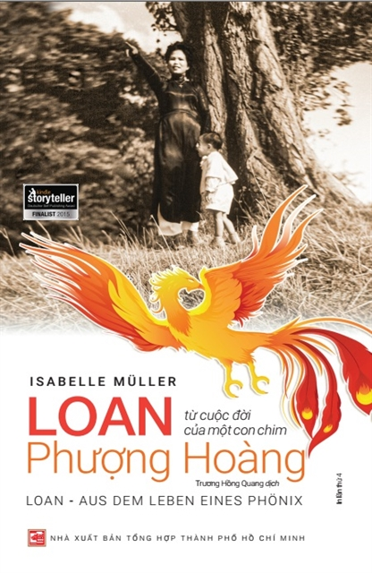
The fourth version of Loan-From a Life of Phoenix will be published in Việt Nam by Hồ Chí Minh City General Publishing House this March. Photo courtesy of the publishing house
HÀ NỘI Hồ Chí Minh City General Publishing House is republishing Vietnamese-German writer Isabelle Müller’s best-selling book Loan-Aus dem Leben eines Phoenix (Loan-From a Life of Phoenix) this March.
This will be the fourth time the biography has been republished in Việt Nam.
Loan-From a Life of Phoenix tells the story of Loan, real name Đậu Thị Cúc, a Vietnamese woman from the central province of Hà Tĩnh, who escaped an arranged marriage at just 12 to set out on a long and often dangerous journey through Việt Nam, Algeria and France to make a life for herself.
According to the HCMC General Publishing House representative, the fourth version of the book, whose copyright has been purchased by the publishing house, will have new cover, design and meticulous corrections of previous versions.
It will be released in March, the month that honours Vietnamese women, with a print volume of about 1,000 copies.
The publisher also owns the copyright of Muller’s best-selling biography, Phoenix's Daughter - Hope Was My Way, published in February 2022.
Based on the sales of these two books, the publishing house will consider releasing a special edition for the two books with either hardcover or a deluxe box this year.
Loan-From a Life of Phoenix and Phoenix's Daughter - Hope Was My Way feature life stories of two outstanding women with Vietnamese blood running through their veins, Loan and her daughter – Isabelle Müller, who have defied fate to succeed brilliantly with their strength, energy and faith. Their lives told in two books have become an endless source of inspiration for many people, especially women.
Loan-From a Life of Phoenix was voted in the top five at the 2015 Kindle Storyteller Awards and was one of the German Amazon bestsellers in 2015.
Since the autobiography was first published in Việt Nam in 2018, it has been well-received by many readers of all ages.
All proceeds from the sale of the book's copyright will continue to be donated to the LO-ANH (LOAN Stiftung) Foundation initiated by Müller, which aims to support poor and disadvantaged children in the northern mountainous provinces.
“For me, it is a great honour to see that my mother´s biography is republished for the fourth time in Việt Nam," Muller told Việt Nam News. "I am so proud of her. Her strength and strong will is kept alive and help many others that are still looking for it to overcome struggles in life,”
“Because HCMC General Publisher has constantly made immense efforts during our cooperation to ameliorate the reading culture in Việt Nam, I was thankful when the decision was taken to publish both books together.
“Publishing or republishing books like mine shows the importance of past experiences and history. Just because both our lives (Mother's and mine) are from "simple" women having to face many struggles and overcome many challenges in life, the readership can fully identify itself with our stories.
“Having the chance as a writer to share them with the readership makes me feel so thankful. It means that my mother´s life and mine make sense and are always worth living, no matter how difficult it was sometimes,” she added. VNS

